**Excel Assignment - 9**

1. What are the different margins options and do we adjust the margins of

the excel worksheet?

**Ans:** There are four margins you can specify: top, bottom, left, and right. Each margin refers to the distance from the edge of the paper to where the information in your worksheet can be printed.Yes, we can adjust margins.

2. Set a background for your table created.

**Ans:** 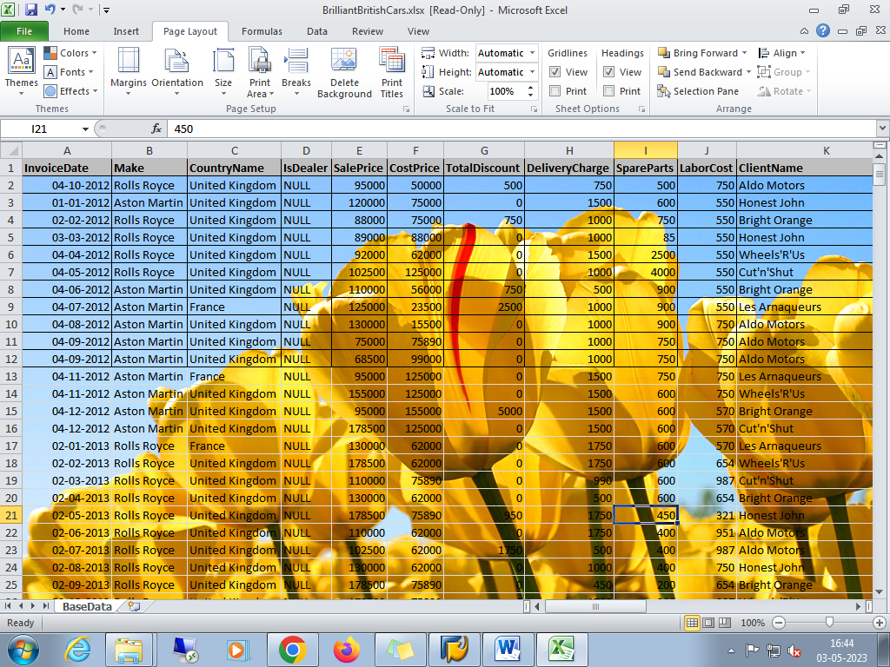

3. What is freeze panes and why do we use freeze panes? Give

examples.

**Ans:** The Excel Freeze Panes option allows you to lock your columns and/or rows so that when you scroll down or over to view the rest of your sheet, the column and/or row will remain on the screen.

Freeze Panes are used to lock any row or column.

Example:

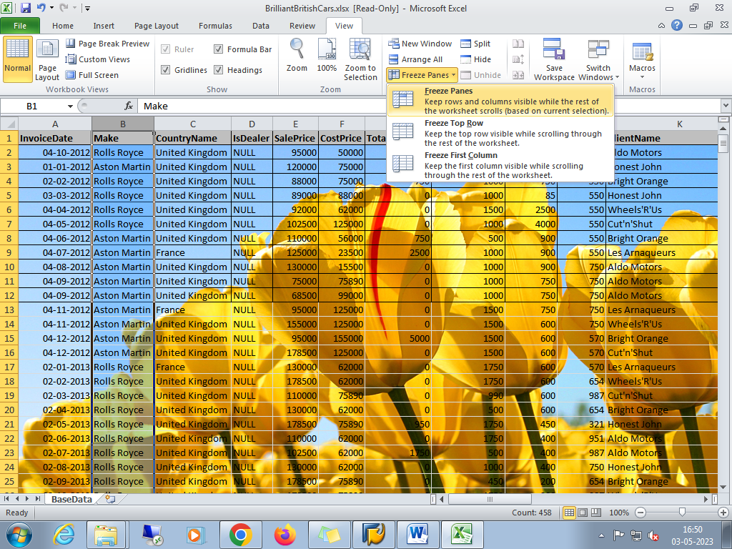

4. What are the different features available within the Freeze Panes

command?

**Ans:** Freeze Pane

Freeze Top Row

Freeze First Column

5. Explain what the different sheet options present in excel are and what

they do?

**Ans:** It allows us to organize vast amounts of data across multiple sheets. Every Excel workbook has at least one sheet. By default, when we create a new Excel file, it usually has three sheets, namely Sheet1, Sheet2, and Sheet3. Furthermore, we can add or delete the desired number of sheets accordingly.

some quick sheet options are also present on the Excel ribbon and can be accessed by going to **Page Layout > Sheet Options.** It mainly has four toggle options: two for **Gridlines** and two for **Headings,** and they can be turned on and off by selecting and deselecting the checkboxes.

Gridlines:

View: This option allows users to show/ hide gridlines within the active worksheet. Turning off this option removes the gridlines from the sheet and displays a blank Excel sheet.

Print: This option allows users to show/ hide gridlines on an Excel document that will be printed on paper.

Headings:

View: This option allows users to show/ hide headings within the active worksheet. Turning off this option removes the headings from the current sheet's headers and footers.

Print: This option allows users to show/ hide headings on an Excel document, which is to be printed on paper.

Sheet Options in Dialogue Box under Page Setup

After clicking on the 'More' option (the arrow icon on the corner of the Sheet Options group on the ribbon), we get various sheet options. These sheet options are mainly used to adjust preferences for printing purposes. For instance, when we print Excel documents, gridlines are not usually printed. We can adjust preferences from sheet options to include the gridlines to print and manage other sheet options.

### Right-click Sheet Options

The right-click sheet options are shown in the following

### i) Insert

### ii) Delete

### iii) Rename

### iv) Move or Copy

### v) View Code

### vi) Protect Sheet

### vii) Tab Color

### viii) Hide

### ix) Unhide

### x) Select All Sheets

### Additional Sheet Options

### i) Grouping worksheets

### ii) Ungrouping Worksheets

### iii) Switching between Worksheets